**Finding the best location to open the food** **court in Ahmedabad, Gujarat, India**

**INTRODUCTION:**

From the last couple of years, Ahmedabad city located in Gujarat, India have experienced numerous openings of new cafes and food courts. Most of them are successfully operating with great number of customers. Consider a small business group wants to invest in building a food court in Ahmedabad. They need to know which is the best location or area to open a food court?

As food courts and cafes have mostly young customers like students or people between 20 – 30 years of age. Optimal location will be the location which has at least one university or one entertainment place within 2/2.5 km of radius.

I have created three data sets using folium. One for existing food courts, second for universities and third for theatres in Ahmedabad. I will map all the data in Ahmedabad map and use circles to observe the radius. Which will help me to shortlist best areas to open the food court without being part in any competition with existing food courts.

DATA: foursquare is used to collect the data of latitude and longitudes along with names and addresses of the universities, colleges, food courts and theatres of all kind like multiplexes, drive-ins etc.

Foursquare provides category ids to target specific location. Which I have used in my project.

Further, this data can be marked in Ahmedabad city map using different colors and we can easily differentiate with circles around the radius as we need to find the location which is at least 2.5 km far from existing food courts.

TARGET AUDIENCE: This type of analysis will help small business groups which invests in local businesses. Current analysis is clearly helpful to them as it clearly defines which areas are good and which are bad for particular business, here in the project, food courts.

USE: the purpose of choosing this topic is that my family member made an investment in one food court which was a failure because of the lacking awareness about target customers and competitions around the same area. Later the same person invested in food court again but considering the above factors and it is successful.

**DATA ACQUISITION AND CLEANING**:

Data coming from foursquare is the data in the json format. Which needs to be cleaned and only important factors are kept instead of keeping every attribute fetched from foursquare.

For that, I filtered results by locating only important attributes and ignoring the rest.

As you can see from two figures: data from figure 1 is converted into data frame with limited attributes.

I did the same approach three times to get three different data frames in this project.

I used foursquare to get the existing food courts in the city, all universities and colleges in the city and all the movie theatres in ahmedabad.

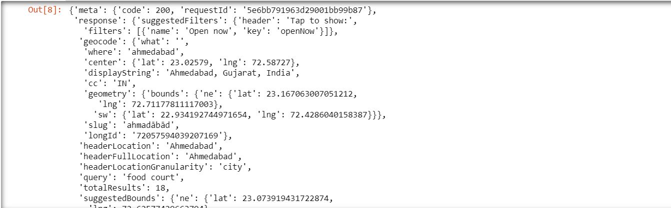

Figure 1

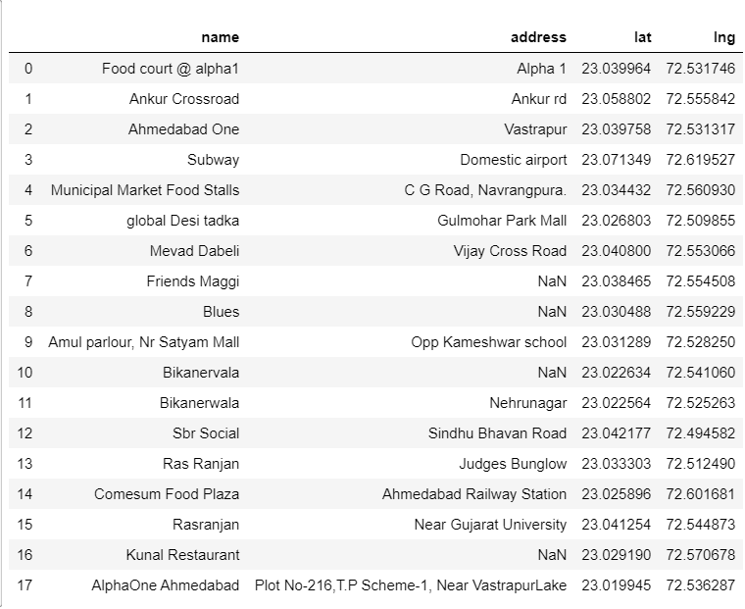

Figure 2

**DATA ANALYSIS:**

I used folium to analyze the data I got from foursquare.

First I got the latitude and longitudes for Ahmedabad city using geopy library. In that map, I mark down the locations of existing food courts from the data frame I got using foursquare.

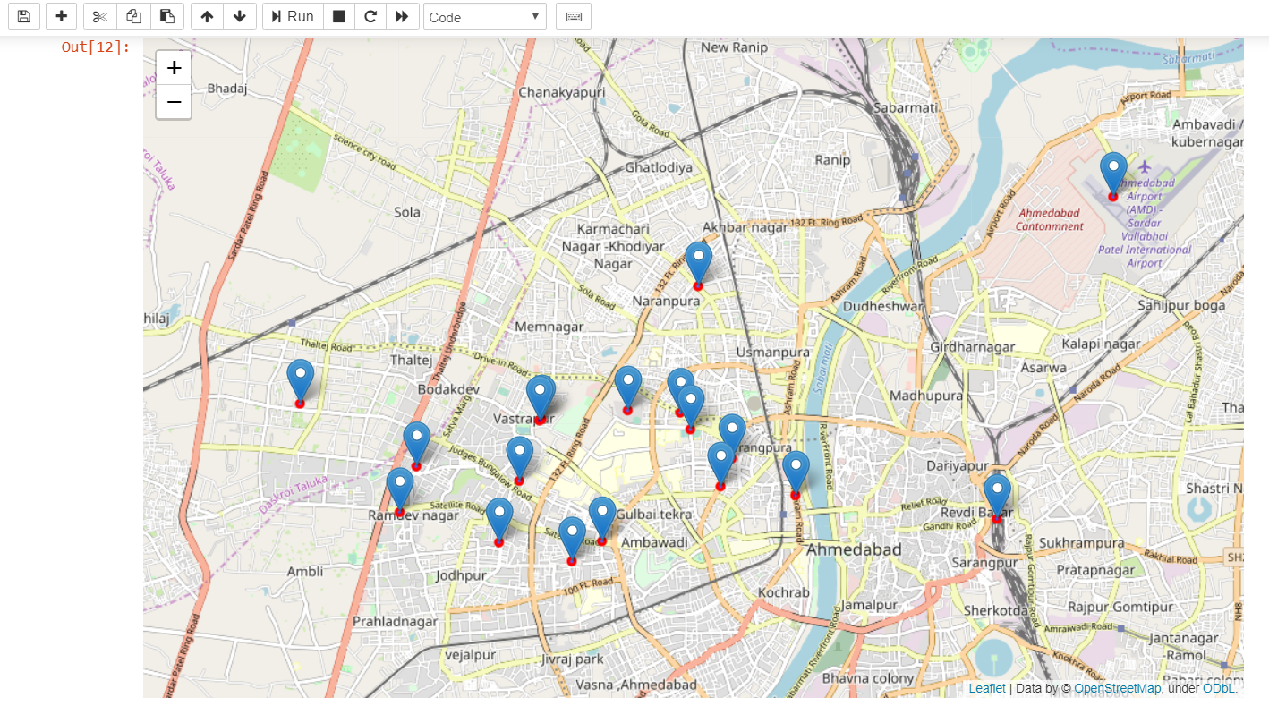

This diagram below shows the green pins which indicates the locations of the universities and colleges in the Ahmedabad city.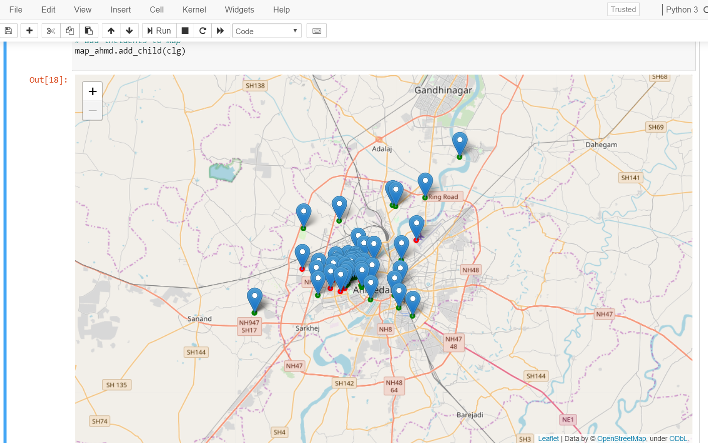 Further, yellow pins show the locations of the existing movie theatres in the ahmedabd.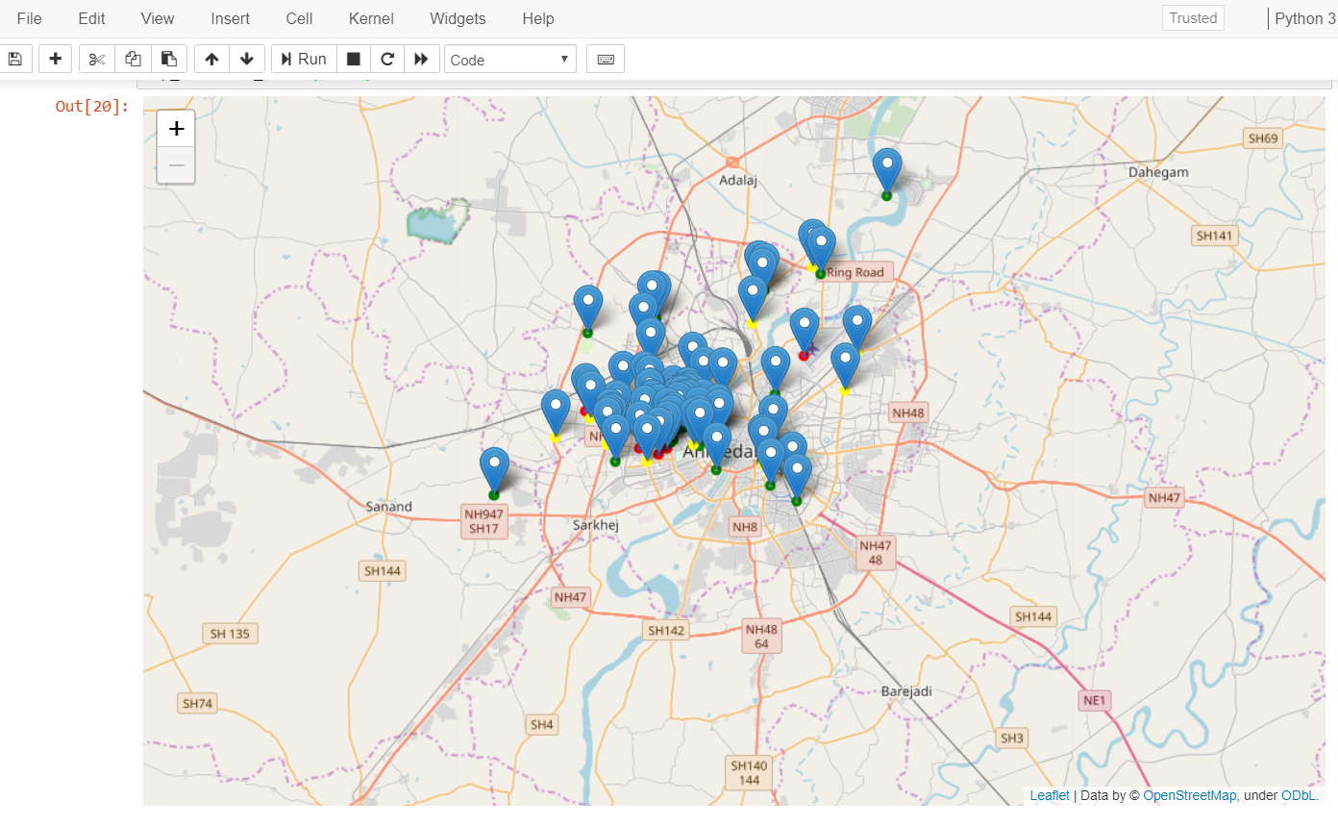

The final part is showed in the following figure. The black circles represents the radius of 2.5 kilo meters of curerntly existing food courts. So as per problem, we need the location outside of the black circles.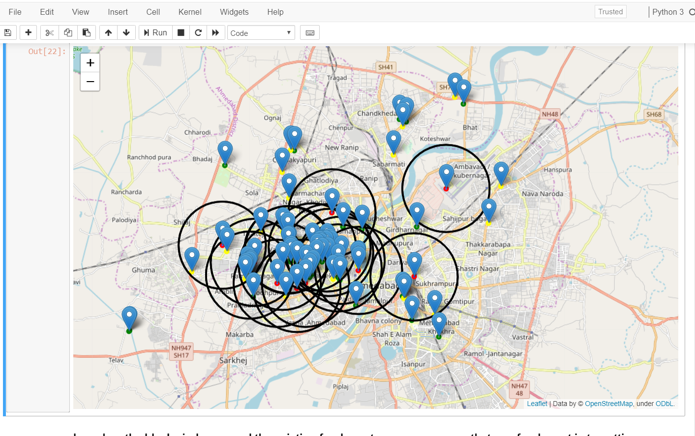

All the area outside the black circles are our filtered locations. We have to find the best location from that and also the location must include at least one university and one movie theatre in its defined radius.

**CONCLUSION**

based on the black circles around the existing food courts, we can assume that one food court is targeting customers from neighborhoods of 2.5 km radius. now we have our options as we can clearly see that areas outside of the black circles are our main target. choosing the location which best fits our requirements are 1. chanakyapuri and 2. chandkheda as both have multiple colleges/universities and multiple theatres in the desired radius. that fulfills our goal.

**FUTURE DIRECTIONS:**

In this project, we have followed only limited factors which we need to open the business. But as per business requirements we can add more attributes like rental prices, geographic area, public surveys etc.

The field of data science is not limited to certain attributes and certain applications. The more you think the more you find.